









Personal Accident

& Medical Expense

Insurance Programme

for 202
6
/2
7

Season

Free To Registered Members of Basketball Ireland.

Policy Number: IEPO000021 Cover effective 01/09/2025..

Cover - Death; Permanent Disablement; Permanent Disabling Injuries, Medical Expenses for injuries sustained whilst participating in a sanctioned Basketball Ireland event/or training.

 |  | Limit |  | Excess
Death | €35,000 (Under 18 €10,000)
Permanent Disablement: | €35,000
Permanent Partial Disability | Up to €35,000
Medical Expenses | Up to €1,500 |  | €75
Physio following accident | Up to €500 |  | €75
Dental Expenses following accident | Up to €500 |  | €75

This is a summary only – For full policy conditions please see policy wording and schedule here:
(Insert Link)

Conditions:
- Medical treatment must be sought within 5 days of injury
- Injury must be from a sudden identifiable incident, repetitive strain injuries are not covered
- Incident report sheet can be found on Basketball Ireland website
- The individual must have a current registration BIPIN.
- Confirmation of membership will be obtained by Arachas from Basketball Ireland.
- Registration data must include a valid personal email.
- Please note that a generic/club email will not be accepted.
Am I covered when I am training? Yes you are covered to and from training whether on your own or with a group.
Does the policy provide oversees coverage?
Yes, sanctioned events only, should have travel cover.
Is this coverage 24/7?
No, the policy is intended for sporting purposes and related activities. For example, you would not be covered going to the shop on your bike.
What costs does the Personal Accident policy cover? There is a €75 excess and the maximum amount payable is €1,500 for Medical expenses. A cap of €500.00 is included in this for Physio treatment following an injury.
NB All injuries to be diagnosed by a GP and certified.

Does the policy provide oversees coverage? Yes.
How do I make a claim?
An incident report form can be obtained from BI website, this can be completed and sent to Basketball Ireland to verify BIPIN. Basketball Ireland will then forward incident report to Arachas who will set up a claim and issue a claim form for completion and notify of any further documents required.

Basketball Ireland Enquiries for claims already reported
Basketball Ireland Arachas Insurance Brokers.

Phone 01-4590211 Phone: 01 - 2135000

email: dlambe@ireland.basketball Email: ngbclaims@arachas.ie

Should you wish to purchase higher limits for your teams this can be arranged for you.
A scheme is in place for Public Liability for clubs this year which will reduce costs significantly for clubs.
Any further queries you may have on this product please contact Anthony Murphy on 01-2135000 or anthonymurphy@arachas.ie.
All insurance queries to be directed to us we are here to assist.



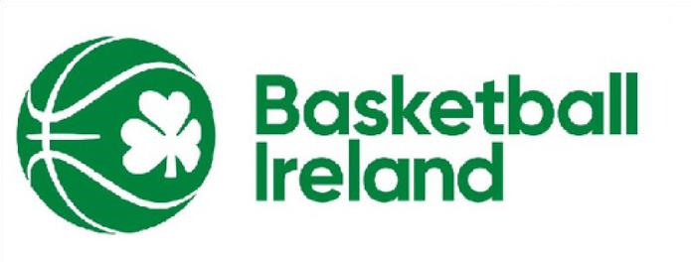





Arachas Corporate Brokers Limited t/a Arachas is regulated by

the Central Bank of Ireland. Registered in Ireland No. 379157.

Arachas Corporate Brokers,

The Courtyard, Carmanhall Rd,

Sandyford Business Park, Sandyford,

Dublin, D18 X377

T:

01
-
21350

E:

anthonymurphy@arachas.ie

