**Basketball Ireland Individual Member User Guide**

User Guide for Members registering to Basketball Ireland



Version 2.0

Table of Contents

Key Contacts 2

All Registrations 2024/25 2

Returning Members 4

New members 12

# Key Contacts

Basketball Ireland

* Support: [info@ireland.basketball](mailto:info@ireland.basketball?subject=Registration%20Support%20query)
* Registration lead – Daryl Lambe: [dlambe@ireland.basketball](mailto:dlambe@ireland.basketball)

GameDay Support

* Support Guide: <https://support.mygameday.app/help>
* Contact Support (email): [support@mygameday.app](mailto:support@mygameday.app)
* Contact Support (contact form): <https://support.mygameday.app/help/contact-feedback>
* GameDay YouTube channel – Passport Training videos (full playlist): <https://www.youtube.com/watch?v=wZRL8LCmou8&list=PLNHxFdCT59xM6AfOeHUuthQu5sRr8ZyWl>
* FAQs for member registrations: <https://support.mygameday.app/help/registration-faqs-for-participants>
* Online learning with eTrainu: <https://gameday.etrainu.com/training/index.cfm?event=page.login&mc_cid=c9ab96f870&mc_eid=5f3c625962>
  + eTrainu are a Learning Management provider that hosts interactive training for GameDay products
  + PLEASE NOTE: The eTrainu platform requires a separate free of charge registration

# All Registrations 2024/25

If you are an individual registering yourself to a club for the 2024/25 season, or a Club representative registering your club to Basketball Ireland, please read this guide. The process will be applicable to all registrations for the new season.

Basketball Ireland are registering all members for the 2024/25 season using GameDay. GameDay requires an email address for all members aged 18 and over, in order to register or re-register. For members aged under 18, then a parent or guardian’s email address will be required.

There will be two types of registration for individual members for the 2024/25 season, returning members (any member that already has a BIPIN) and new members (someone that has never been registered with Basketball Ireland previously).

In order to register successfully, members will complete a registration form issued via their Area Board. You can access the links to each Area Board’s registration form here: <https://ireland.basketball/registration>

Both returning and new members will follow the same process to register. Once you have been sent your link by your club or Area Board, you will see the sign-in screen.

If you already have a Passport account, either as a member returning to this organisation, the sport or another sport that uses GameDay Passport, you will be able to enter your password and proceed through the form using the **CONTINUE** button.

# Returning Members

If you have previously registered with Basketball Ireland you will need your email address used from your previous registration, as well as your BIPIN before proceeding.

If you are a returning member, please use the same email address that was registered with us for the 2023/24 season. This will help avoid delays when Basketball Ireland are processing your application.

The first step will be to confirm the number of members you wish to register:

The GameDay system will allow you to register multiple people in one session. This is especially useful for a family that wishes to register everyone at the same time to the same email account.

If you do NOT wish to register members to the same email, it is advisable to register each member separately.

**PLEASE NOTE: Each registration must contain a personal/parents/guardian’s email, in order to be deemed correctly registered and covered by Basketball Ireland’s ‘Player Injury Scheme’**

Next, you will be asked to provide your email address:

If you have logged in and registered to Basketball Ireland via GameDay previously, you should use the email address you previously used to register with on GameDay.

Once entering your email address, the system will request a password:

If you cannot remember your password, please follow this link: <https://support.mygameday.app/help/registrations-forgot-password>

You will receive an email asking to confirm your email address and create a new password, once confirmed you will see your name and BIPIN on the left-hand side of the next screen.

All members registered to your email address should appear on the next screen with the format FIRST NAME SURNAME BIPIN: 0000000

Basketball Ireland requires members to re-register with your club from last season. Once you have re-registered all transfers will be processed. If you register with your new club without re-registering to your old club your application may be rejected by Basketball Ireland.

The system will ask you to register with your club from last season:

If you are registering for a different Club this season, your record will require a Transfer from your previous Club. This means you will still have to register for your old Club before transferring.

If you do not register with your previous Club your membership application will be rejected.

Once you select your member name and BIPIN, you will see your previously saved details:

You must define all roles the member will be fulfilling this year. The roles you can register as are:

* Player
* Coach
* Match Official
* Commissioner
* Volunteer
* Table Official
* Team Manager

If you are registering for multiple member types e.g. Player and Table Official, please TICK ALL that apply to you before selecting. The system will require at least one member type to be selected.

The next stage will be to provide information to complete your membership form in the ‘Questions’ section:

Any previously held data you have provided will be displayed from Passport e.g. address, phone number (please update accordingly if any changes apply):

You will be asked to read Basketball Ireland’s Terms & Conditions for the new season. These have been updated from last season so please make sure you have read and understood the policies before continuing:

The final step will be to make payment. Basketball Ireland will charge members for the highest paid product from your chosen member types:

You will then be taken to the payment screen to make your payment. Payment can be made via credit or debit card and Google Pay:

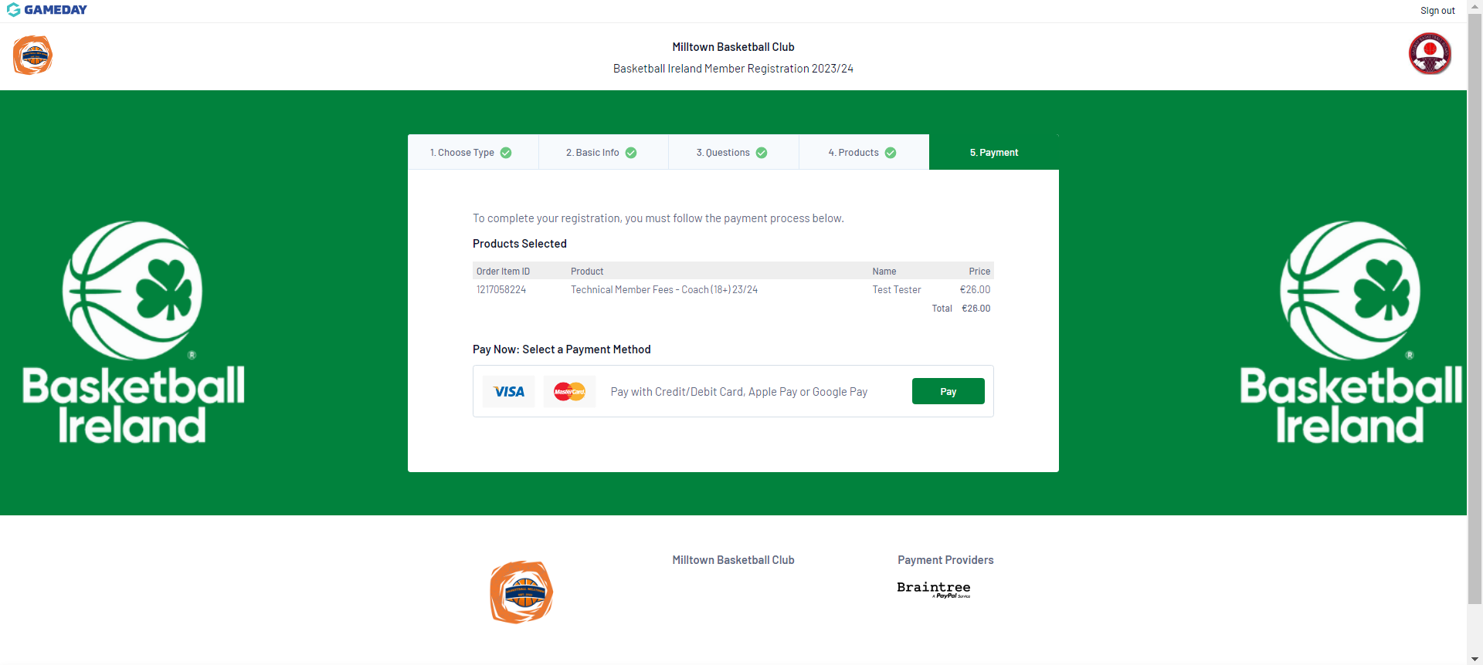

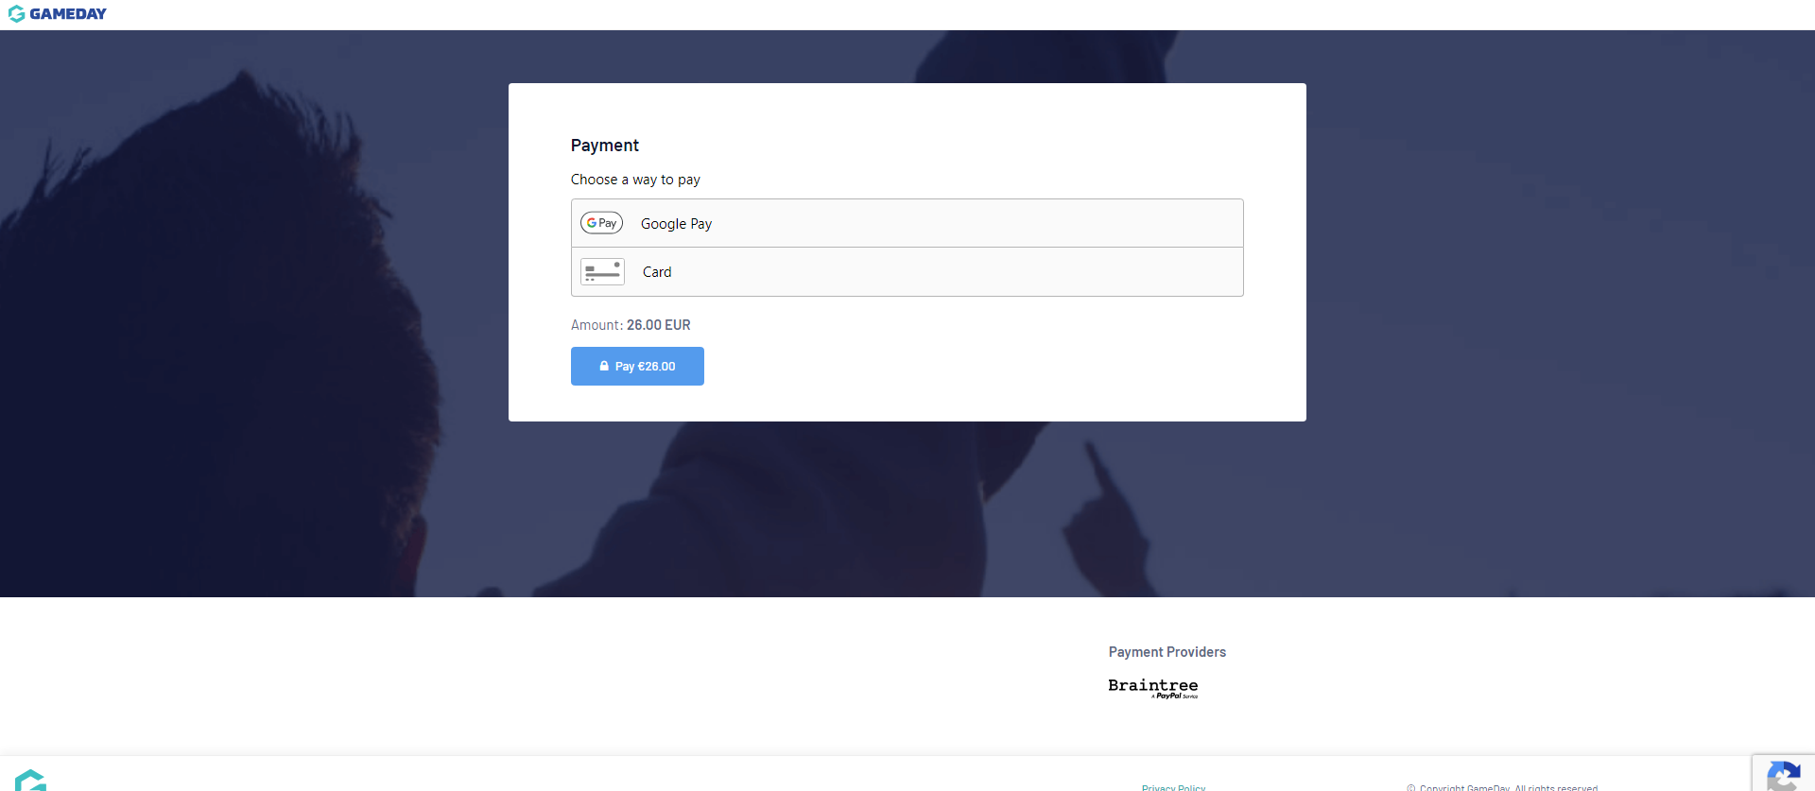

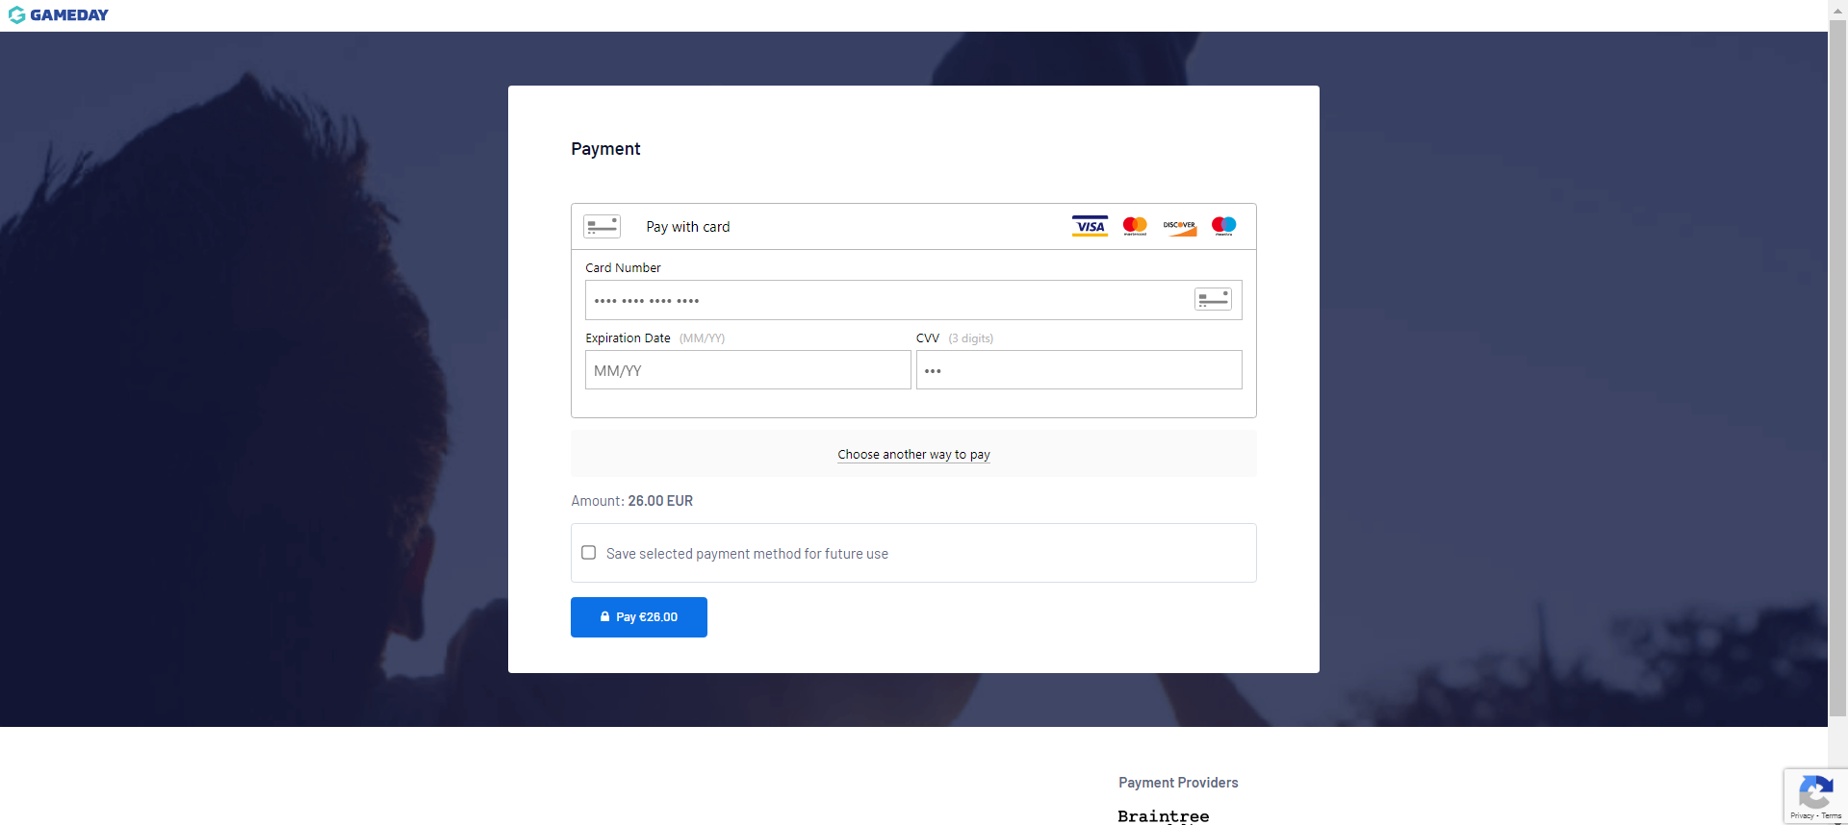

Once your payment has been made you will be returned to the confirmation screen:

You will receive an email confirming your registration application has been submitted. Your application will be sent to Basketball Ireland for review.

PLEASE NOTE: If you have chosen multiple member types, only the product will appear here. Your confirmed membership will hold all chosen member types, which you can view in your member profile:

<https://membership.mygameday.app/dashboard/?r=85>

Members can view the information held for themselves on Passport on the member profile. More information on navigating this can be found on the GameDay Support guide: <https://support.mygameday.app/help/member-profiles#navigating-your-member-profile>

# New members

If you are a new member, please use the email address you wish to have registered with us for the 2024/25 season onward.

You will need to create a new account to register, once confirmed you can select the Club you are registering for this season from the dropdown option in the centre of the screen.

**PLEASE NOTE: Each registration must contain a personal/parents/guardian’s email, in order to be deemed correctly registered and covered by Basketball Ireland’s ‘Player Injury Scheme’**

If you do not already have a GameDay Passport account, you can choose to register as a new member using the YES, I'M NEW option on the next page:

When you enter the form, a list of all clubs within the relevant Area Board will appear in the dropdown list. You will be asked to register with a club from your new Area Board. The system will provide you with all options within the region:

Once you have chosen your club, the name at the top of the registration form should be the same as the club you have chosen:

You will then be asked to enter your details. The information required in this screen will be:

* First name
* Surname / Family name
* Date of Birth
* Gender at Birth

You must define what roles the member will be fulfilling this year. The roles you can register as are:

* Player
* Coach
* Match Official
* Commissioner
* Volunteer
* Table Official
* Team Manager

If you are registering for multiple member types e.g. Player and Table Official, please TICK ALL that apply to you before selecting. The system will require at least one member type to be selected.

The next stage will be to provide information to complete your membership form in the ‘Questions’ section:

You will be asked to complete a series of fields providing information about yourself to complete your application. Please provide all relevant information at this stage. If any information is not provided this may delay the approval of your application.

PLEASE NOTE: The form does not save information that you can return to later. GameDay advises that you complete the requested information in the same session.

You will be asked to read Basketball Ireland’s Terms & Conditions for the new season. Please make sure you have read and understood the policies before continuing:

The final step will be to make payment. Basketball Ireland will charge members for the highest paid product from your chosen member types:

You will then be taken to the payment screen to make your payment. Payment can be made via credit or debit card or Google Pay:

Once your payment has been made you will be returned to the confirmation screen:

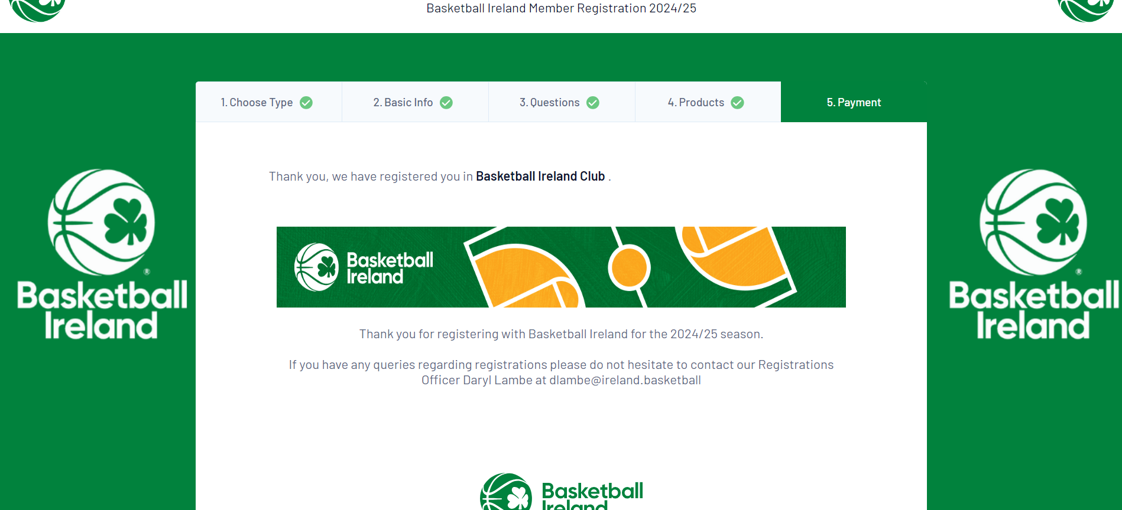

You will receive an email confirming your registration application has been submitted. Your application will be sent to Basketball Ireland for review.

PLEASE NOTE: If you have chosen multiple member types, only the product will appear here. Your confirmed membership will hold all chosen member types, which you can view in your member profile:

<https://membership.mygameday.app/dashboard/?r=85>

Members can view the information held for themselves on Passport on the member profile. More information on navigating this can be found on the GameDay Support guide: https://support.mygameday.app/help/member-profiles#navigating-your-member-profile