Registering Individual Members
To register as an individual go to: https://basketballireland.sport80.com/

- Log into your account using your email and password – ensure you are logged into the account with the email which the member(s) are registered under.
- You will then be brought to the following screen:
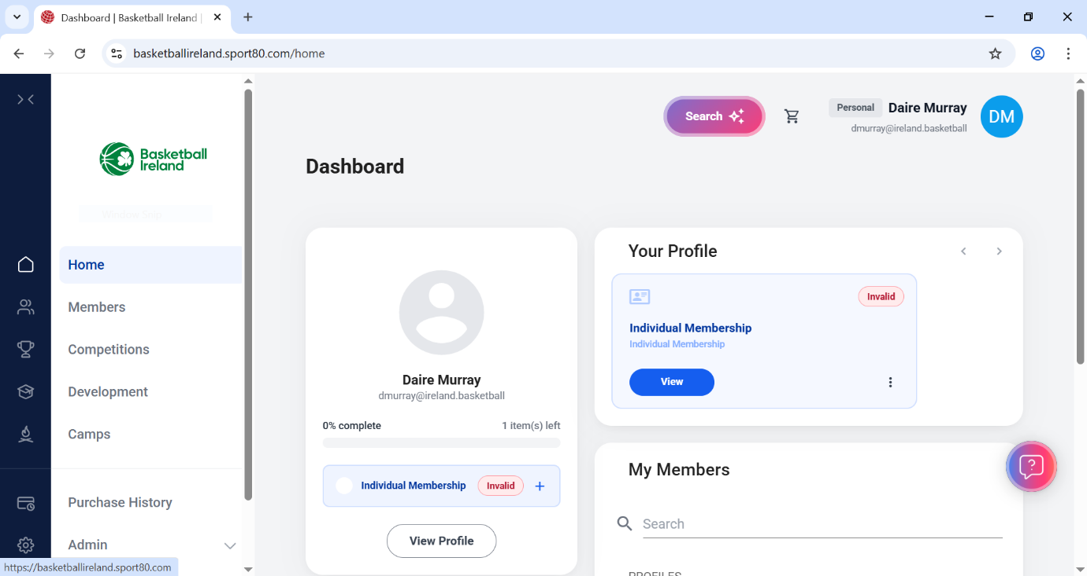
- Using the menu on the left side of the screen, select ‘members’ (circled in red in below image.
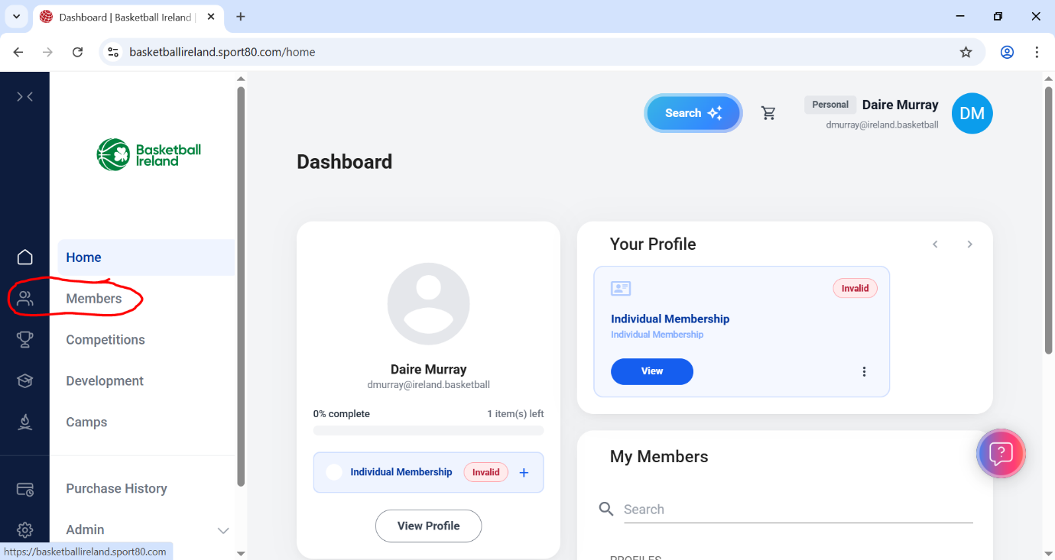
- From here, select the member you want to register, and you will be brought to the page seen below.
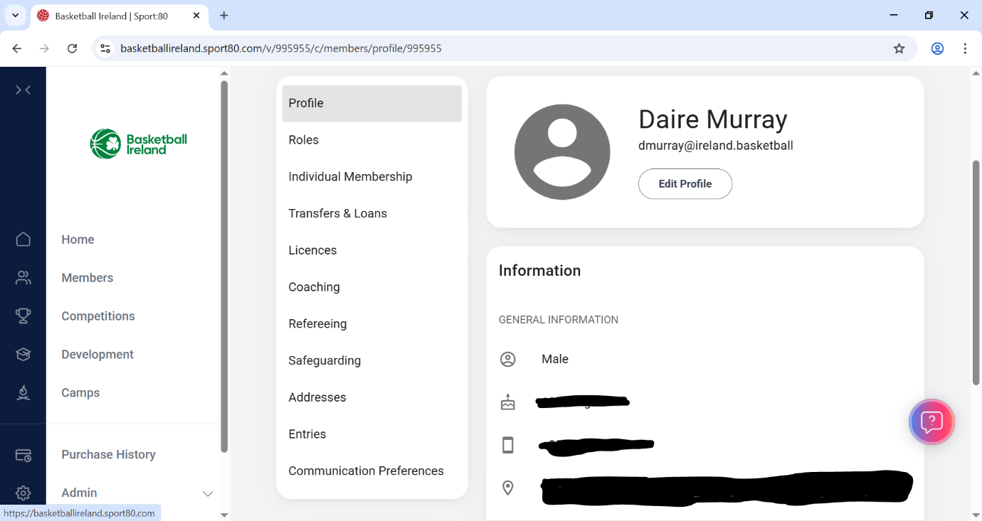
- Select ‘Individual Membership’.
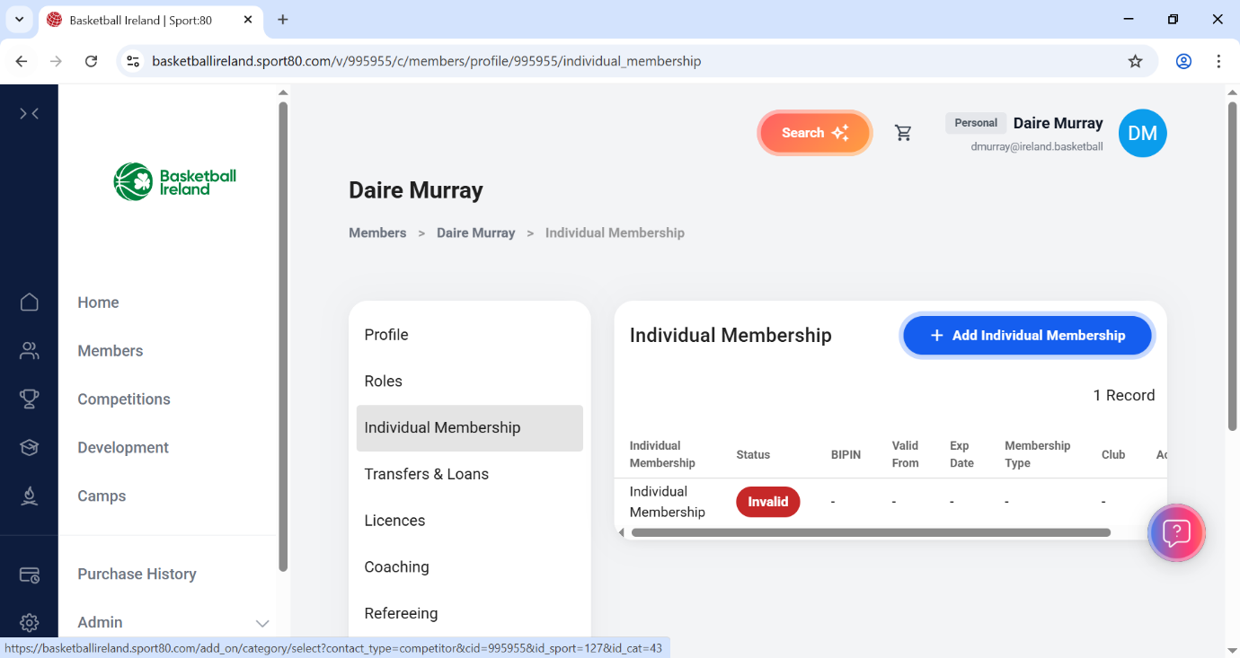

- Click ‘Invalid’ – this will open the renewal page.
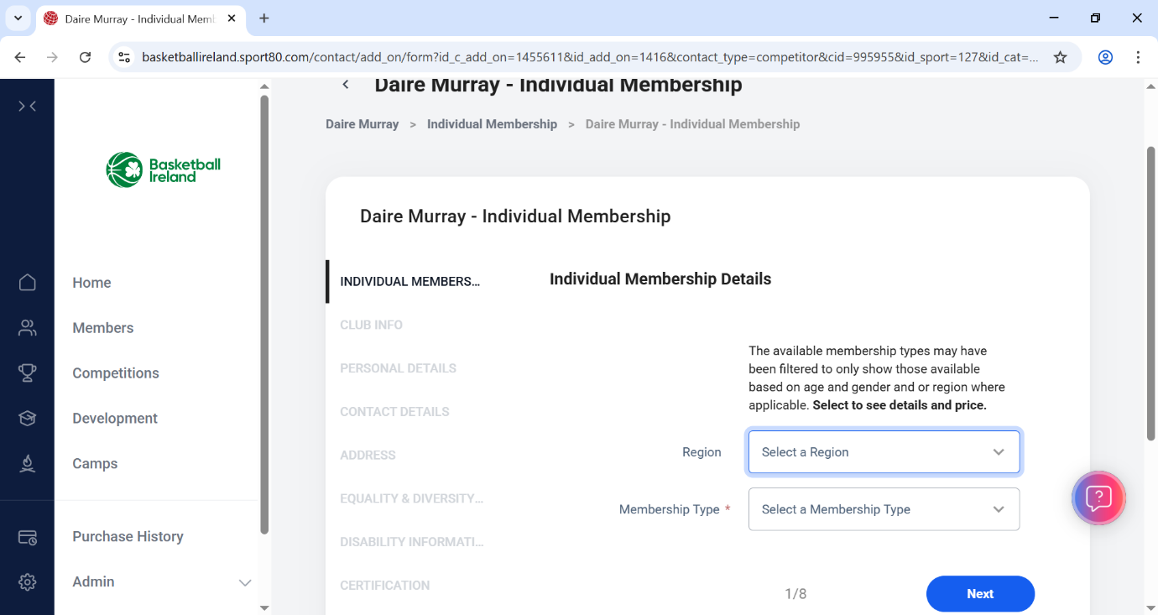
- Please select the geographical region of your club and then choose the membership type relevant to you.
- Proceed to the next page:
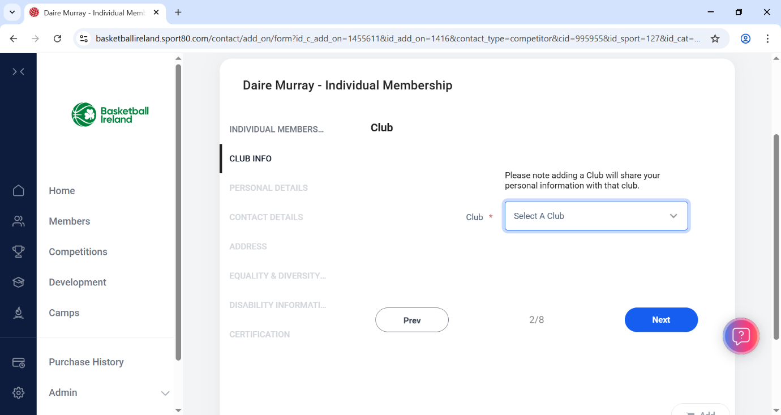
- Please select your club from the dropdown menu, if your club does not appear this means they have not yet completed the registration process with us for the current season, and you will not be able to proceed until they do so.
- Select your club and click next.
- You will then be asked for various information to ensure we have the most up to date details for all of our members, once all compulsory questions have been answered you will be taken to the check out to complete your purchase.
- To save changes, select the ‘add’ button at the end of the last page of the forms. See below image:
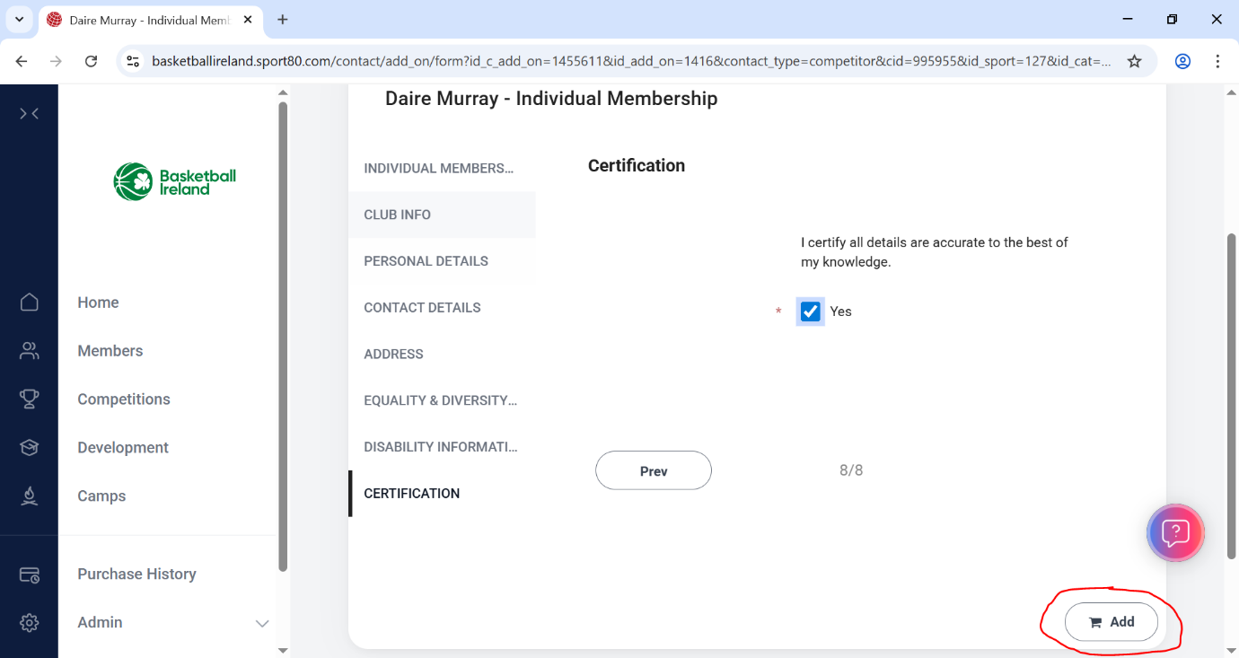

- For any member that is a referee, table official, coach, commissioner, or National League Player, select the ‘Add licences’ box and proceed to add the relevant licences to your cart.
- For any member that is just a player/volunteer, select ‘checkout’.
- If registering multiple players, you can click ‘not now’, then select ‘members’ across the bar which is under the current player that you are registering’s name. This will bring you back to the page with all members under the current email address, and you can proceed to select the next member to register and repeat the above steps.
