

HIGH PERFORMANCE HEAD COACH U16 MEN’S NATIONAL TEAM

CANDIDATE APPLICATION INFORMATION

SEPTEMBER 2024



## ABOUT US

Basketball Ireland has responsibility for the promotion, development and administration of all basketball activities in Ireland and Northern Ireland. The primary focus of Basketball Ireland is to increase the participation levels of basketball throughout Ireland and to provide professionally managed courses, competitions, leagues and services to the basketball public.

The Board of Basketball Ireland, comprised of voluntary members, governs overall policy.

Basketball Ireland has over 250 grassroots clubs island-wide, with a 50/50 gender split and a community of players, coaches, officials and volunteers of over 100,000, with a basketball fan base of 800,000.

## OUR MISSION

To grow the sport of basketball through strong leadership, professional management and empowerment of volunteers.

.

## OUR VISION

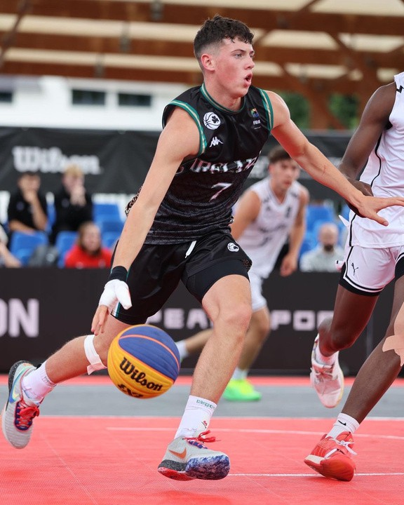Basketball is everywhere and for everyone.

## OUR VALUES

Integrity

We operate with respect and as a team. Inclusion

We are compassionate and embrace diversity.

Courage

We lead by example and do the right thing.

Ambition

We are progressive and strive for excellence.

01

w w w . i r e l a n d . b a s k e t b a l l

**The Opportunity**



w w w . i r e l a n d . b a s k e t b a l l

02

Basketball Ireland would like to appoint a Head Coach of Basketball Ireland's U16 Men’s National Team for 2024-2025.

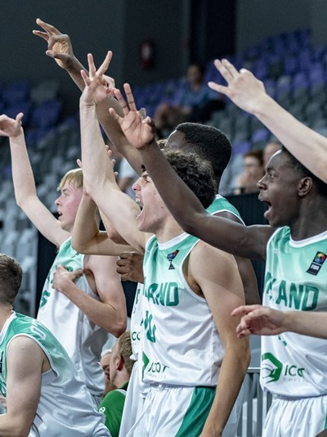

The appointment will begin on 9 Sept with National Team Trials on 14th &15th Sept in University of Limerick.

Candidates must be available for all National Team Programme practices and games. Please see National Team Programme calendar link.

Head Coaches must also nominate a staff team, with suitable background and experience, to the EPC for approval. The staff team will include Team Manager, two assistant coaches and a physiotherapist.

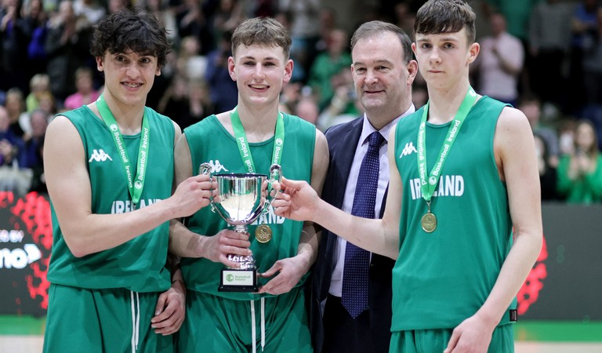

# HEAD COACH DUTIES AND RESPONSIBILITIES

03

|  |
| --- |
| INDUCTION AND TRAINING |
| Attend induction, consultations, training, and meetings as required by the EPC. |
| RECRUITMENT AND SELECTION |
| Recommend a suitably qualified staff team (two assistant coaches, team manager, physio) for appointment to EPC.  Have clear squad selection criteria that are shared with coaching staff and players. Select players to the squad and final 12 in line with EPC eligibility policy and  guidelines. |
| COMMUNICATION |
| Maximise the use of XPS (BI National Team Performance Management system) for all business related to National Teams  Communicate with National Team Programme staff, EPC, and players in a timely  fashion. |
| TECHNICAL PLAN |
| Develop an appropriate technical plan for the National Team programme and share with assistant coaching staff and EPC via XPS. |
| POLICY AND PROCEDURE ADHERENCE |
| Comply with all Basketball Ireland and EPC policies and procedures.  Reinforce to all staff all regulations as laid out by the EPC and Basketball Ireland. Report any concerns about other staff conduct / behaviour to the EPC Liaison.  Abide by the Basketball Ireland Code of Conduct and Code of Ethics and all other  relevant policies. |
| COACHING PROCESS |
| Lead the coaching team to develop and implement the training programme for all players on the squad.  Carry out a risk assessment at all training venues.  Organise and supervise all training sessions and matches, in accordance with the agreed master calendar from Basketball Ireland.  Deploy assistant coaches to lead practice session delivery under your supervision when appropriate. |

**HEAD COACH DUTIES AND RESPONSIBILITIES**

#### HEALTH AND SAFETY

Ensure that all coaching duties are conducted taking due care of health, safety, and welfare without putting at risk the health, safety and welfare of yourself, colleagues, players, and members of the public.

Ensure that any accidents / injuries which occur at any Irish International training or matches are recorded via the National Team Manager and team physiotherapist.

Ensure National Team Manager reports and records injuries or illness on the BI accident report form.

#### BEHAVIOUR

Abide by BI Code of Conduct for Coaches.

With the National Team Manager manage the behaviour of the management team.

In collaboration with the Team Manager be responsible for the behaviour of all players ensuring no players consume any alcohol or take illegal drugs at any International Basketball event.

#### STANDARDS

Ensure the programme represents Ireland with the highest possible level of professionalism.

Act as an ambassador for Basketball Ireland, promoting its interest and refraining from public criticism.

Observe confidentiality of information that is confidential to the EPC. The restriction continues to apply after the completion of the volunteer role.

Wear BI Coaching attire at National Team Programme practices and competitions. Should there be any problem with your position the EPC will follow a problem-solving process to establish clarity on the problem, initiate meeting/s to review the problem and instigate resolutions. If no resolution can be found volunteers can be removed.

Report any concerns about other staff conduct / behaviour to the EPC Liaison. Reinforce to all staff all regulations as laid out by the EPC and Basketball Ireland. Comply with all Basketball Ireland and EPC policies and procedures.

#### MONITORING AND EVALUATION

Support ongoing monitoring and evaluation of National Team Programme by participating in conversations with EPC liaison/& EPC Chair to establish programme goals and implementing any EPC monitoring and evaluation tools.

Completion of National Team Programme Report. Attendance at National Team Programme Review Meeting.

04

# Head Coach Specification

#### ESSENTIAL CRITERIA

1. Level 1 coaching qualification or equivalent from a different country. 2. Safeguarding Children and Young People.

3. Garda Vetting/Enhanced Access NI.

4. Extensive knowledge of Basketball Ireland's Code of Ethics for Children’s Sport.

#### ESSENTIAL EXPERIENCE

1. Appropriate basketball coaching experience for the position applied for.
2. Committed to and has a proven track record of personal development and a willingness to embrace feedback.

#### ESSENTIAL SKILLS AND COMPETENCES

 Excellent interpersonal and communication skills.  Excellent management and organisation skills.

 Excellent planning, delivery, and reflection skills.

 Ability to work as part of a team, but also use their own initiative.  High level leadership skills.

 Ability to empathetically manage difficult conversations.  Ability to motivate.

 Shows integrity and is fair, equitable and ethical in approach.

 Able to adhere to policies and procedures as outlined by Basketball Ireland.  Willing to use the XPS system for National Team Operations

#### DESIRABLE CRITERIA

 International team coaching experience.

 Experience in running a high performance coaching programme.

 Can work as a team and demonstrate the ability to plan and coach, utilising a range of performance resources e.g. Strength and conditioning, nutrition and sport psychology.

05

w w w . i r e l a n d . b a s k e t b a l l

# Service Details

#### VOLUNTARY SERVICE

 The National Team Head Coach position is a voluntary role

 A volunteer agreement between the successful candidate and BI must be signed on appointment.

 The successful candidate will receive travel and subsistence expenses funded through the national team programme.

#### TIME COMMITMENT

 Appointments to begin on 9 Sept 2024 and conclude on the completion of National Team Programme Report post FIBA Youth Championships 2025.

 Availability for practice sessions, performance camps, stand-alone sessions, coach workshops as per national team programme calendar.

#### LOCATION

* Practice session locations will vary across the island of Ireland dependent on facility availability.
* The successful candidate must be eligible to travel worldwide.

#### SUPPORT

 Coaches will, where possible, be offered coach development sessions over the course of the National Team Programme.

 An Elite Performance Committee (EPC) liaison will assist where possible, by advising on any policy queries and providing advice and support. The liaison can be a confidante for any management staff member.

 Head Coach will complete a National Team Programme Report for the Elite Performance Committee (EPC), so that enhancements can be made annually.

#### OTHER FACTORS

 Be prepared to work unsocial hours.

#### HOW TO APPLY

 Please complete the application form and send with a “Basketball CV” to Christine Connolly, Head of International and Schools Operations via email on [cconnolly@ireland.basketball.](mailto:cconnolly@ireland.basketball)

·

#### THE PROCESS

 Closing date for application is Wednesday 4 Sept 5pm

 Interviews will take place on Friday 6 Sept (time to be arranged)

w w w . i r e l a n d . b a s k e t b a l l

06



Phone Number

### + 353 1 4590211

Email Address

### [cconnolly@ireland.basketball](mailto:cconnolly@ireland.basketball)

Website

### [www.ireland.basketball](http://www.ireland.basketball/) Facebook

@bbireland **Instagram** @basketball_ireland

### X

@BballIrl **LinkedIn** basketball-ireland **Tik Tok**

@basketball.ireland

07

w w w . i r e l a n d . b a s k e t b a l l

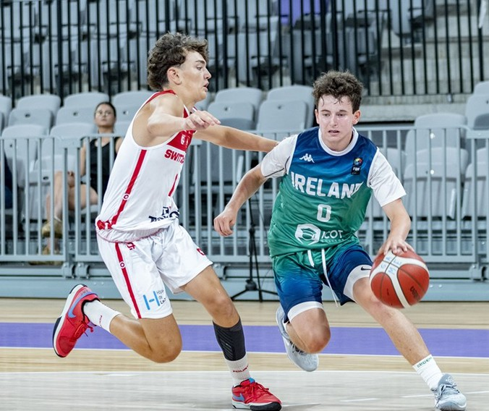

BASKETBALL IRELAND HIGH PERFORMANCE

w w w . i r e l a n d . b a s k e t b a l l