**Competition Entry**

* Log into Sport80 as the club administrator.
* Select ‘Competitions’ on the left hand side of the screen (circled below).

* The below page will open. Press ‘Enter Now’ on the relevant competition.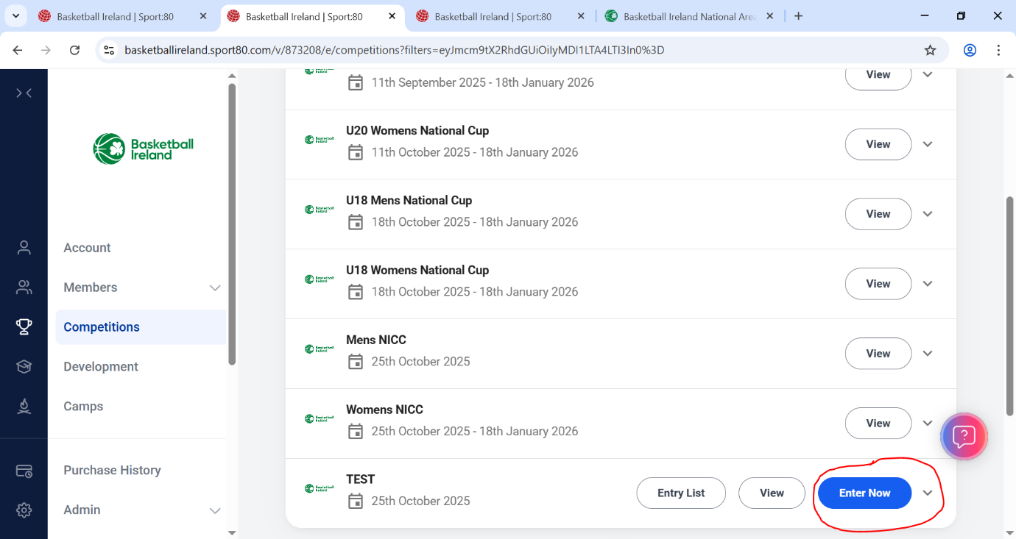
* Once here, select the blue ‘Actions’ box and a dropdown menu will appear. From the dropdown menu, select ‘+ Enter New Team’. (See two images below which display this step)A screenshot of a computer

  AI-generated content may be incorrect.A screenshot of a computer

  AI-generated content may be incorrect.
* The window below will open. Fill in all relevant details for the team that is wishing to enter the competition. Once this information is filled in, press next and fill in the contact details relevant to the specific team that is entering the competition. Once these details are filled in, click ‘save’ in the bottom right corner. This will save your entry form. You will be brought back to the page shown in the third image. Select the team you have just entered and you can make payment there.

